

|  |  |  |
| --- | --- | --- |
|  | **Mathematics Department**  **11 Maths Methods Test 4 Odd**  **Trigonometry Graphs, Cubics, Probability and Circle Measures** | |
| **Name** |  |

**Section 1 – Resource Free – Students can have the formula sheet**

**Marks : 29 Time: 30 minutes (maximum)**

**1. [7 marks]**

For the graph of **y = x3 - x2 - 4x + 4**, determine:

(a) the coordinates of the point where the curve cuts the y-axis,

(b) the coordinates of the points where the line cuts the x-axis (you may need to use the factor theorem to help you do this).

(c) Draw a sketch of this graph.

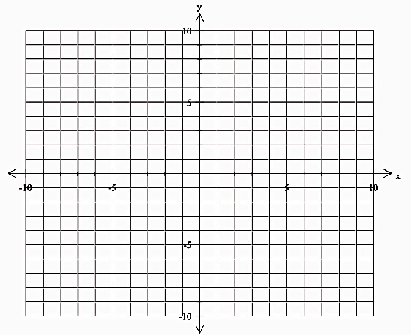

**2. [1, 1, 2 = 4 marks]**

(a) Express  in radians leaving your answer as a multiple of  (in simplest form).

(b) Express  radians in degrees

(c) Find exactly, the exact value of 

**3. [5 marks]**

Give the amplitude and period of:

(a) y = 4sin(3x – 90°) + 1

(b) Draw a sketch of y = 4sin(3x – 90°) + 1 0° ≤ x ≤ 360°

|  |  |  |  |  |  |  |  |  |  |  |  |  |  |  |
| --- | --- | --- | --- | --- | --- | --- | --- | --- | --- | --- | --- | --- | --- | --- |
|  |  |  |  |  |  |  |  |  |  |  |  |  |  |  |
|  |  |  |  |  |  |  |  |  |  |  |  |  |  |  |
|  |  |  |  |  |  |  |  |  |  |  |  |  |  |  |
|  |  |  |  |  |  |  |  |  |  |  |  |  |  |  |
|  |  |  |  |  |  |  |  |  |  |  |  |  |  |  |
|  |  |  |  |  |  |  |  |  |  |  |  |  |  |  |
|  |  |  |  |  |  |  |  |  |  |  |  |  |  |  |
|  |  |  |  |  |  |  |  |  |  |  |  |  |  |  |
|  |  |  |  |  |  |  |  |  |  |  |  |  |  |  |
|  |  |  |  |  |  |  |  |  |  |  |  |  |  |  |

**4. [5 marks]**

Given , P(A) = 0.4 and P(B) = 0.5,

a) find  (2)

b) find P(A|B) (2)

c) Are events A and B independent? (Justify your answer) (1)

**5. [4 marks]**

Give the equation of each of the following graphs:

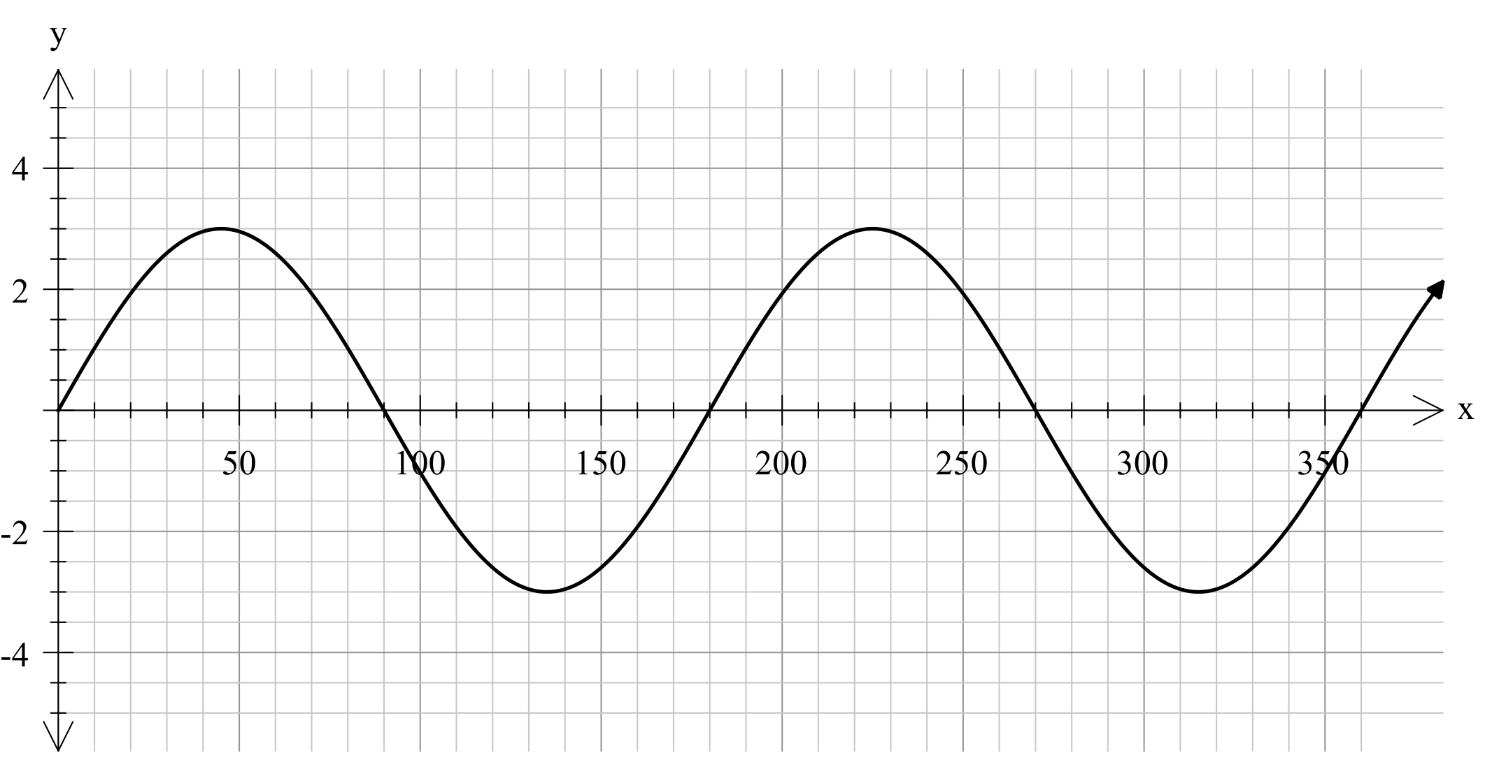

______________________________

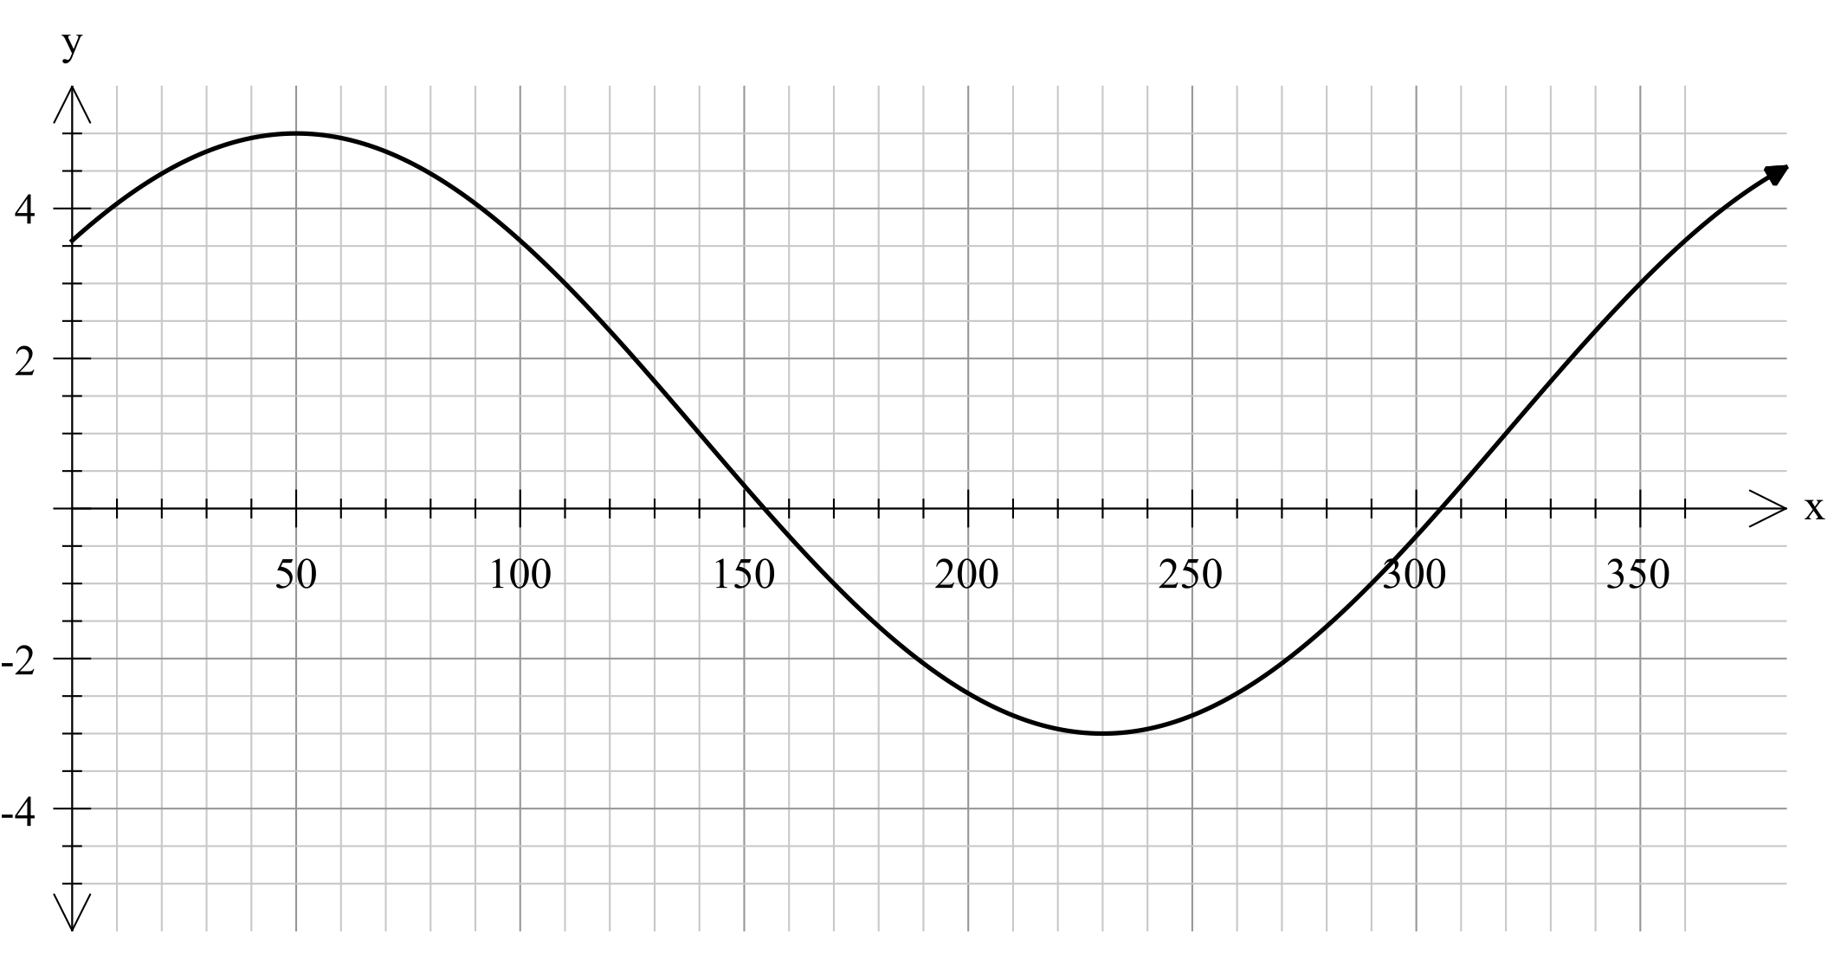

________________________________________________

**6.** **[4 marks]**

(x - 2) and (x + 1) are factors of x3 - 4x2 + px + q.

Find p and q and determine the third factor of the cubic expression



|  |  |  |
| --- | --- | --- |
|  | **Mathematics Department**  **11 Maths Methods Test 4 Odd**  **Trigonometry Graphs, Cubics, Probability and Circle Measures** | |
| **Name** |  |

**Section 2 – Resource Rich – calculators, formula sheet and 1 page of notes**

**Marks : 31 Time: 30 minutes (minimum)**

**7. [5 marks]**

Some Year 12 students purchased 30 items from two surf shops; High Tied and Surf Down.

The following table shows how many Tops, Shorts and Jeans were purchased from each shop.

|  |  |  |  |
| --- | --- | --- | --- |
|  | Tops | Shorts | Jeans |
| High Tied | 4 | 9 | 4 |
| Surf Down | 3 | 8 | 2 |

Two items were chosen at random from the group of 30. **Without evaluating answers,**

(a) Determine how many different ways there are of choosing the two items. [1]

Find the probability that:

(b) they were both from High Tied. [1]

(c) one was from each shop. [1]

(d) both were from the same shop. [1]

(e) neither was a top and neither was from High Tied. [1]

**7. [5 marks]**

A deer farmer believes that the profit/loss of his farm may be affected by weather conditions. His computer is set up with appropriate software and the following table produced.

|  |  |  |  |
| --- | --- | --- | --- |
|  | Weather Favourable (F) | Weather Unfavourable () |  |
| Profit (P) | 0.52 |  | 0.65 |
| Loss () |  | 0.23 |  |
|  | 0.64 |  | 1.00 |

(a) Complete the table.

(b) Find the probability that he makes a profit and the weather is unfavourable.

(c) Find the probability that the weather was favourable, given that he makes a loss.

**8. [6 marks]**



A sector of a circle is shown in the diagram opposite.

a) If r = 8cm and  = 50°, find the perimeter of the sector

(accurate to 1 decimal place).

b) If the radius is 9cm and the perimeter is 31.5 cm, find the size of  in radians.

c) Given that the area of the sector is 62cm2 and  = 1.4 radians. Find the radius of the sector (accurate to 2 significant figures).

**9. (7 marks)**

The diagram below shows a pair of intersecting circles with centres at P and Q with radii of 5 cm and 6 cm respectively. RS is the common chord of both circles and PQ is 7 cm.

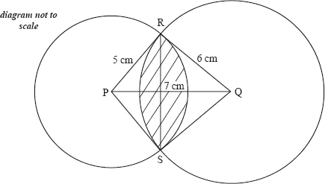

Find the area of the shaded region.

10 [8 marks]

The clinical records of a large eye hospital indicate that

* 58% of patients are blue eyed (set )
* 42.9% of patients belong to the blood group O (set )
* 31.9% of patients are blue eyed and do not belong to blood group O

(a) Use this information to complete the probabilities  to  in the tree diagram below.



(b) What is the probability that a randomly selected patient will

(i) belong to blood group O and have blue eyes? (1 mark)

(ii) have blue eyes or belong to blood group O? (1 mark)

(iii) not have blue eyes, given they do not belong to blood group O? (2 marks)